**SR UNIVERSITY**

**AI ASSISTED CODING**

**ASSIGNMENT 7**

**NAME:** MOHAMMED MUTAKABIR HUSSAIN

**H.NO:** 2503A51L35

**ASSIGNMENT 7.4**

**TASK 1**

**Task Description #1:**  
• Introduce a buggy Python function that calculates the factorial of a number using recursion.  
Use Copilot or Cursor AI to detect and fix the logical or syntax errors.  
**Expected Outcome #1:**• Copilot or Cursor AI correctly identifies missing base condition or incorrect recursive call and  
suggests a functional factorial implementation

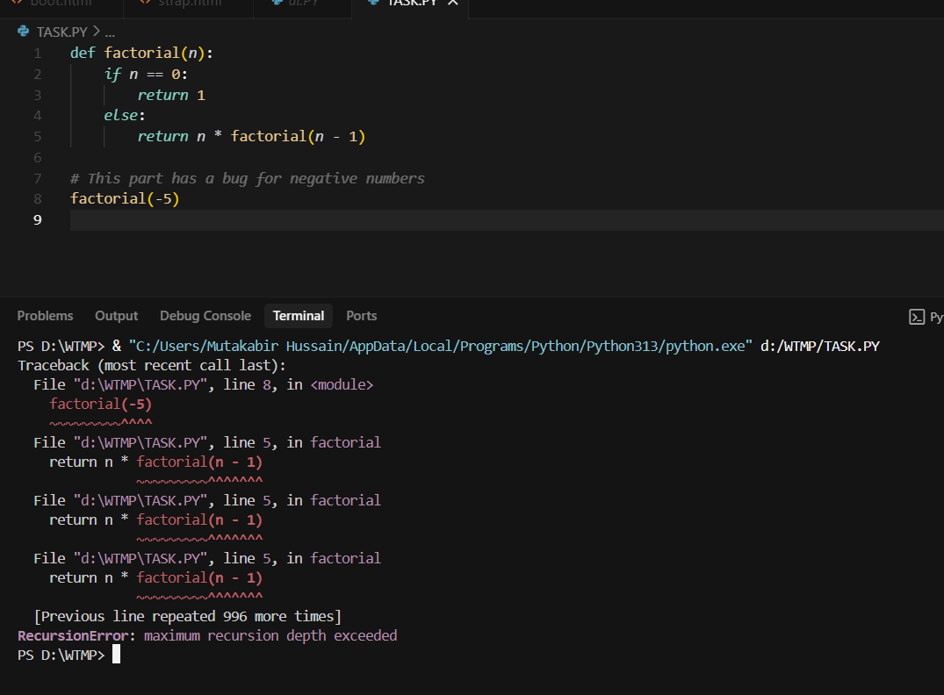

**Prompt:**

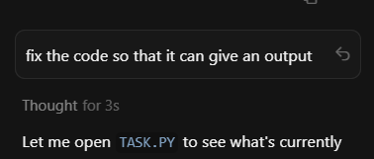

**Code:** 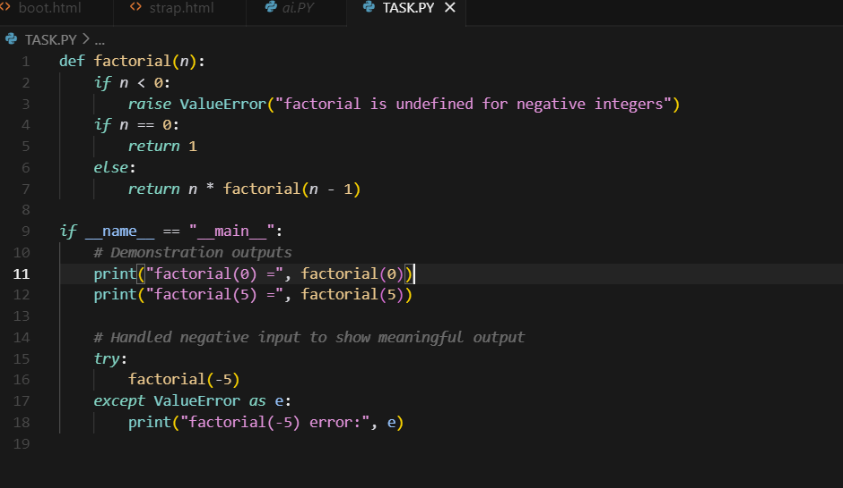

**Output:** 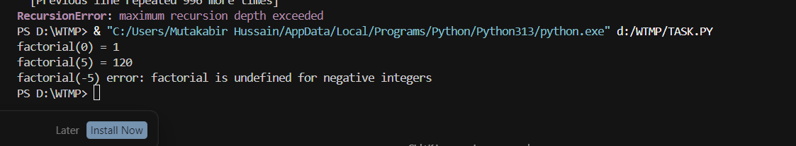

**Observation:**

When a buggy python code was used it showed errors so when I used cursor AI and commanded it to fix it and we got a running python code with output

**TASK 2**

**Task Description #2:**  
• Provide a list sorting function that fails due to a type error (e.g., sorting list with mixed  
integers and strings). Prompt AI to detect the issue and fix the code for consistent sorting.  
**Expected Outcome #2:**  
• AI detects the type inconsistency and either filters or converts list elements, ensuring  
successful sorting without a crash  
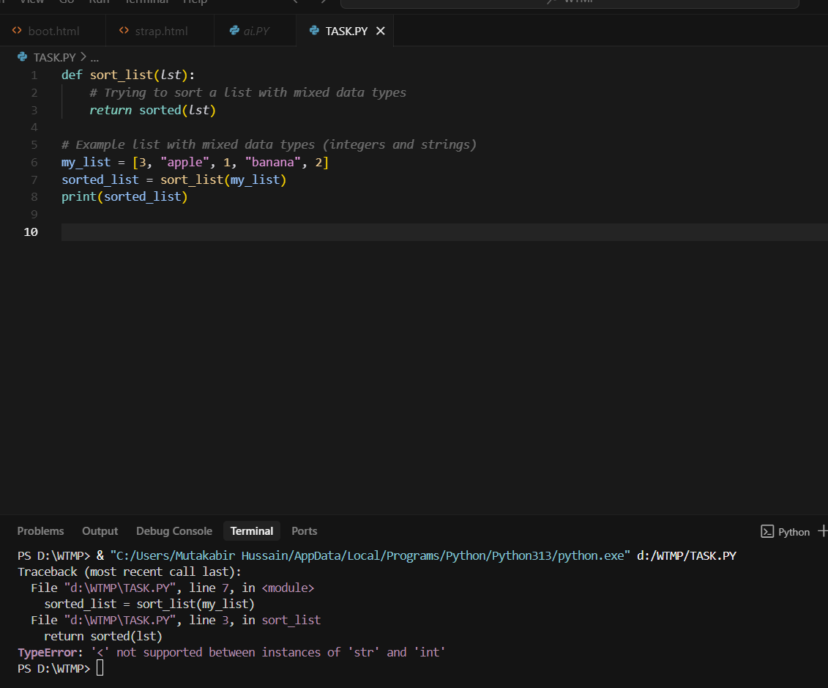

**Prompt:**

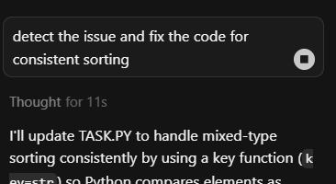

**Code:** 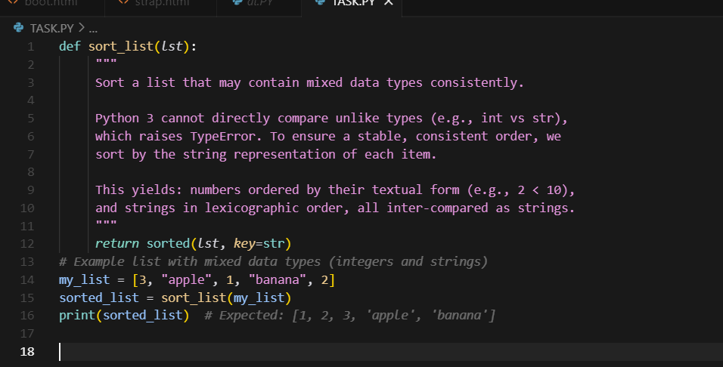

**Output:** 

**Observation:**

AI detects the type inconsistency, bugs in the code and ensuring gave a code which   
successfull sorting without a crash

**TASK 3**

**Task Description #3:**  
• Write a Python snippet for file handling that opens a file but forgets to close it. Ask Copilot or  
Cursor AI to improve it using the best practice (e.g., with open() block).  
**Expected Outcome #3:**  
• AI refactors the code to use a context manager, preventing resource leakage and runtime  
warnings. 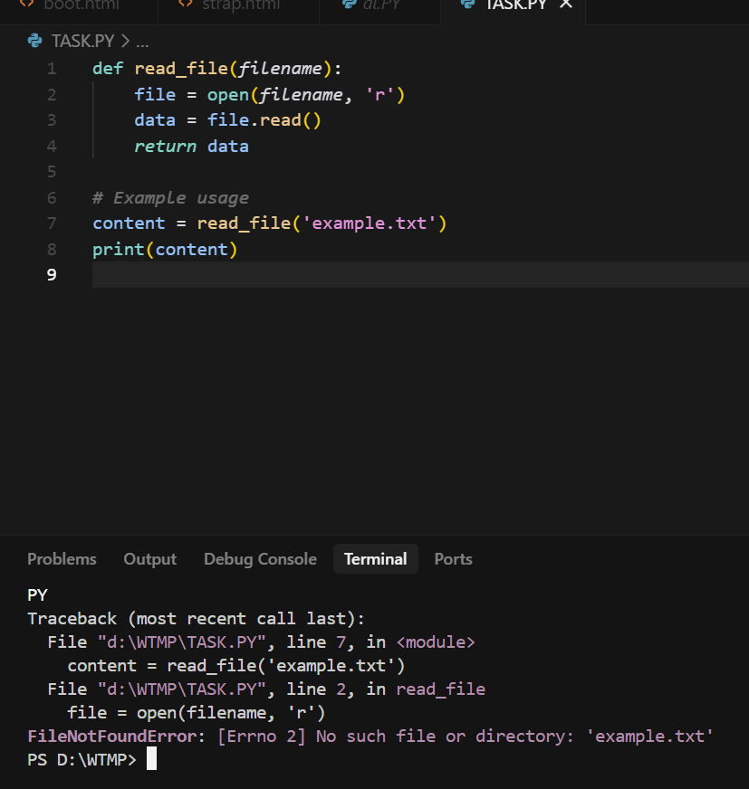

**Prompt:**

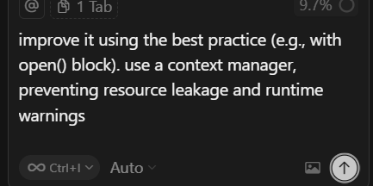

**Code:** 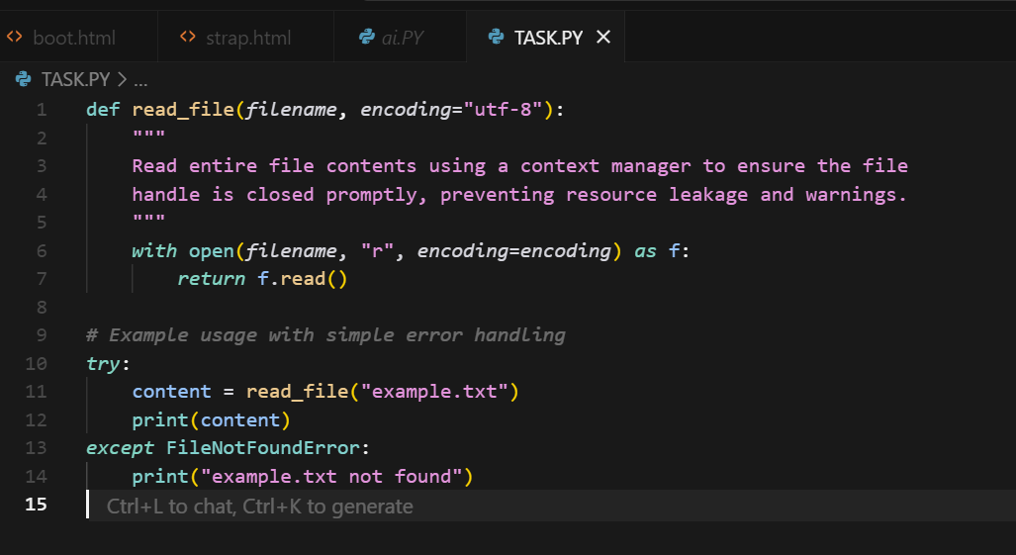

**Output:** 

**Observation:**

cursor AI improve it using the best practice with open() block using a context manager, preventing resource leakage and runtime warnings

**TASK 4**

**Task Description #4:**  
• Provide a piece of code with a ZeroDivisionError inside a loop. Ask AI to add error handling  
using try-except and continue execution safely.  
**Expected Outcome #4:**  
• Copilot adds a try-except block around the risky operation, preventing crashes and printing a  
meaningful error message

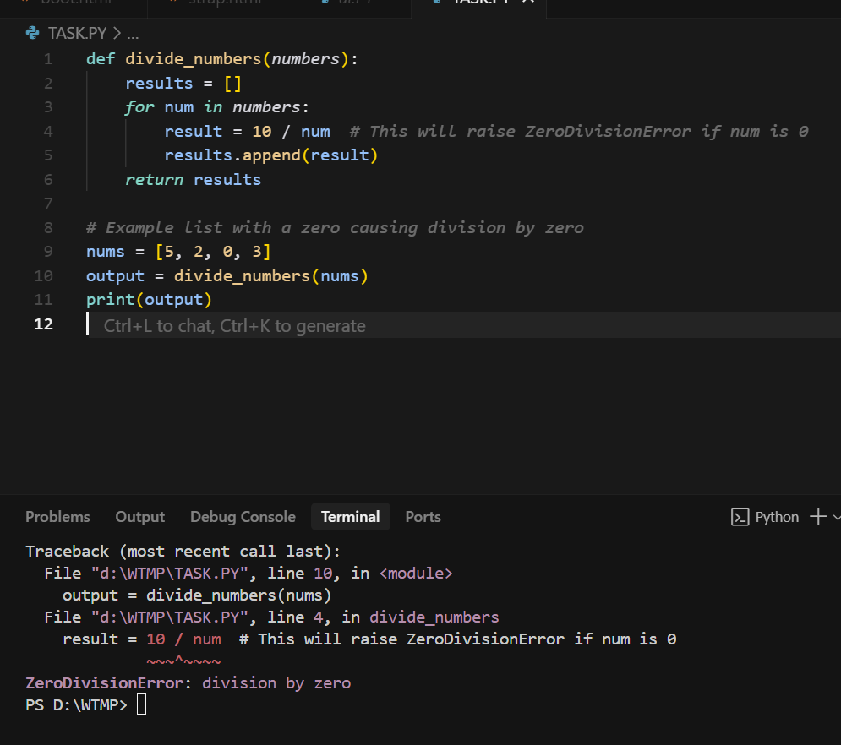

**Prompt:**

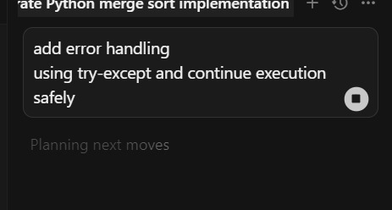

**Code:** 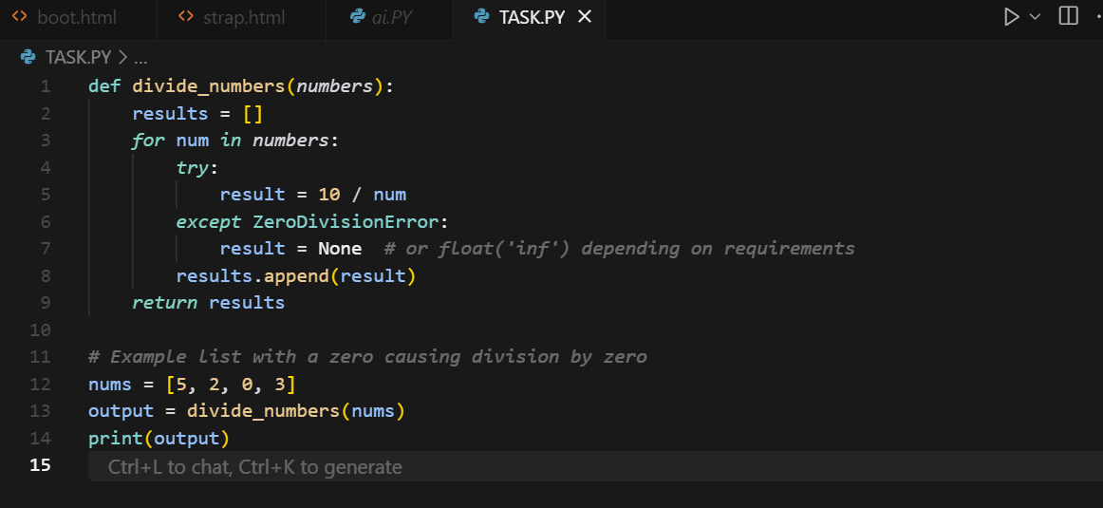

**Output:** 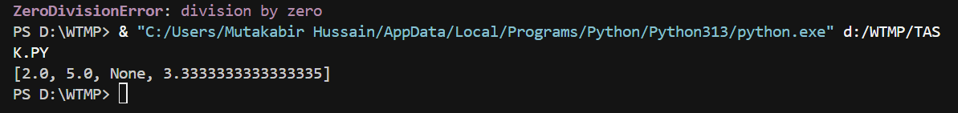

**Observation**:

The loop crashes with ZeroDivisionError when dividing by zero Cursor AI can fix it by using try-except and continue execution safely.

**TASK 5**

**Task Description #5:**  
• Include a buggy class definition with incorrect __init__ parameters or attribute references. Ask  
AI to analyze and correct the constructor and attribute usage.  
**Expected Outcome #5:**  
• Copilot identifies mismatched parameters or missing self references and rewrites the class with  
accurate initialization and usage.

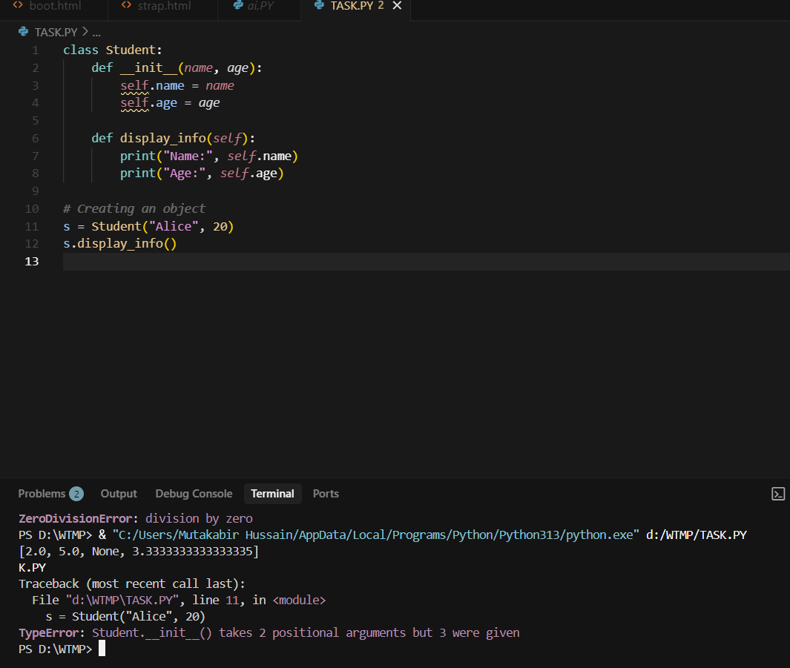

**Prompt:**

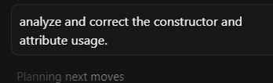

**Code:** 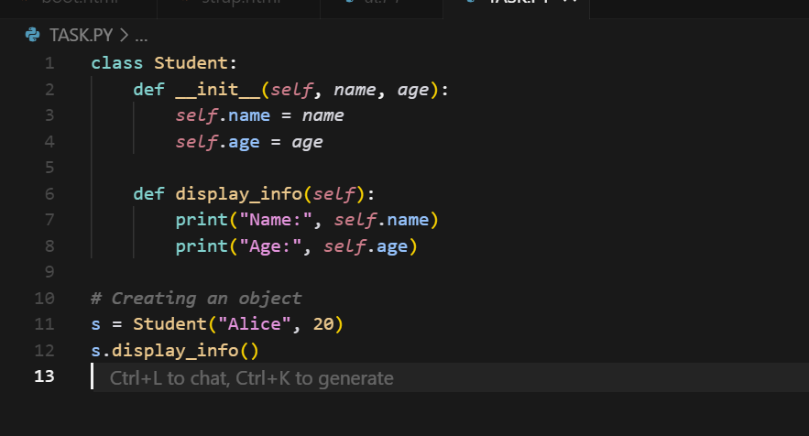

**Output:** 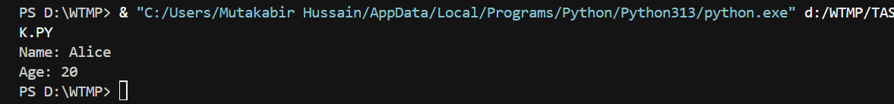

**Observation:**

Cursor AI identifies mismatched parameters or missing self references and rewrites the class with  
accurate initialization and usage.